Rent Smart Wales
Official Guide

How to bulk import registered properties to your registration

Dated 15/08
This guide is produced by Rent Smart Wales. www.rentsmart.gov.wales 03000133344
This training guide was supplied by Rent Smart Wales. Copyright © 2015 rentsmart.gov.wales 0300133344
The following document explains how you use the Import Properties function when adding registered properties to your registration.
Contents

1.0 CSV Template and Importing 2
Updating the Registered Property List after import 4

1.0 - CSV Template and Importing

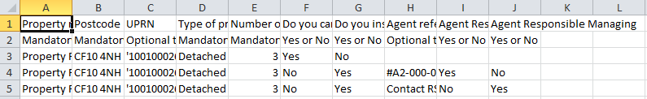
The CSV template will look like this. As you can see, there are instructions included within the CSV to help you fill in the information correctly; the three example lines after the header row must be deleted before you do your import.
Property Reference
This is a mandatory column, meaning you cannot leave this blank. We suggest making the property reference the first line of the address.
Postcode
This is a mandatory column. The Postcode column is where you type in the postcode of the property, ensuring there postcode is correctly formatted with the space in the correct part of the postcode, e.g. CF10 4NH.
UPRN
This is optional text. This means Unique Property Reference Number. Most people may not be aware of their UPRN, so you are not required to enter this.
Type of Property
This is a mandatory column. Type of Property is the best suited description of the property using the following options; only one option can be used:
Description | What word to use in .CSV column
Detached Property | detached
Semi-detached Property | semidetached
Self-contained flat in a purpose built block or converted building | Flat
Shared Property or Property in Bedsits | Shared
Terraced Property or End of Terrace | Terrace

Number of Bedrooms
This is a mandatory column. You will be required to put a digit in this column that reflects the amount of bedrooms this property has e.g. 3. This must be in a numeric format.

Do you carry out letting or management activities at this rental property?
This is a mandatory column, in which you must answer the question by either entering Yes or No into the column’s field.
To find out if you should answer yes or no, you can read our Frequently Asked Questions page: https://www.rentsmart.gov.wales/en/faqs/#9Do you instruct a person/company to do letting or management work on your behalf at this property?
This is a mandatory column, in which you must answer the question by either entering Yes or No. Please note: You can only select yes if you know the agent reference number; otherwise the import will not work. If you don’t know what the agent reference number is (it will be reference that follows the following format #A2-000-0000) then contact Rent Smart Wales and we can check our system and advise you of it. If the agent does not have a reference (as they have not started the application process yet), then you will need to say in the .CSV import that you don’t have an agent by writing ‘no’ in this column so that it works. Afterward the import you will have to edit each record and add the agent there (see process in 2.0 below).
The following three columns are only mandatory if you have said you have got an agent (because you have the #A agent reference)
Agent Reference
This is where you add the #A reference you have. .
Agent Responsible Letting
This is a mandatory column, where you must answer whether the agent whose reference you have added is responsible for letting work at the rental property. Answer the question by either entering Yes or No into the column’s field.
Agent Responsible Managing
This is a mandatory column, where you must answer whether the agent whose reference you have added is responsible for management work at the rental property. Answer the question by either entering Yes or No into the column’s field.
You can read the following section on our FAQ section on our website to see if your agent does letting and/or management at one of your rental properties in Wales: https://www.rentsmart.gov.wales/en/faqs/#14
Once you have filled in all these details, you will need to save the file in a CSV format (remembering to delete the three example rows after the header before you do so) and then upload it to the site using the Browse and Import buttons:
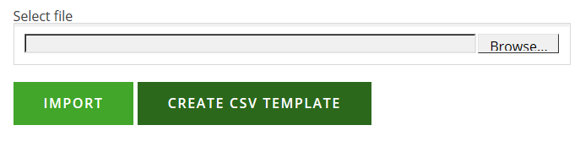
If your file uploads successfully, a similar pop up will show (depending on the amount of records you want to upload) to the image below and you will then need to go back to your registered property list using the back button.
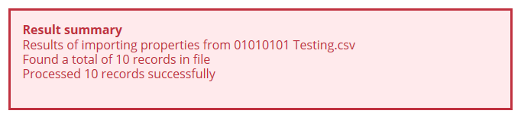

2.0 - Updating the Registered Property List after import

In this example, Spencer Davies has uploaded the following CSV template:

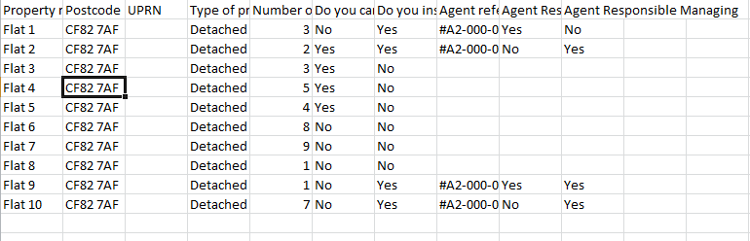

If you have already entered an Agent Reference number within the CSV and it is entered correctly, the Agent will automatically be invited to link the property to their Agent Profile and you should find their details under the ‘Connected Agents’ details in the ‘View Property’ Section.

If you use an agent, and no agents are listed in the ‘View Property’ Page, you must ‘Add Agent’ by clicking the pink ‘Add Agent’ button. They will only show as ‘officially connected’ once they accept an email invitation from Rent Smart Wales to link with your rental property; this is done so the agent has the opportunity to confirm that they ‘let and/or manage it’. 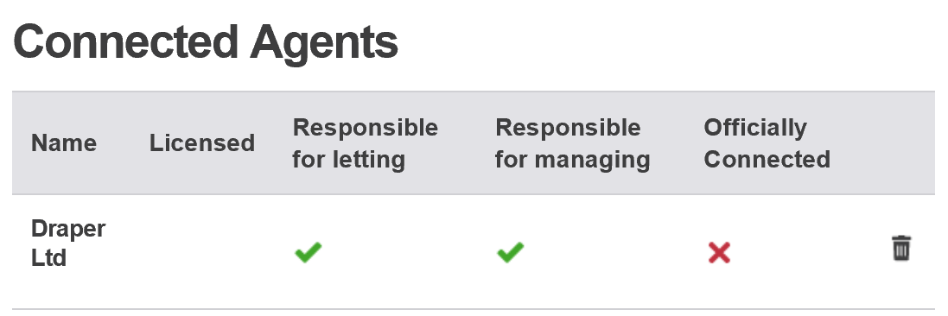
Once you have finished updating your rental addresses, press back.

Then repeat the updating process with another property (by going through the yellow pencil) or press ‘Next’ to carry on with your Landlord Registration.
When Spencer has returned to her Registered Properties page, she will be greeted by the following information <add picture!>. As you can see, the CSV does not pull through the address. For this reason, you will need to click the little yellow pencil in order to complete the property record.

View once yellow pencil clicked:
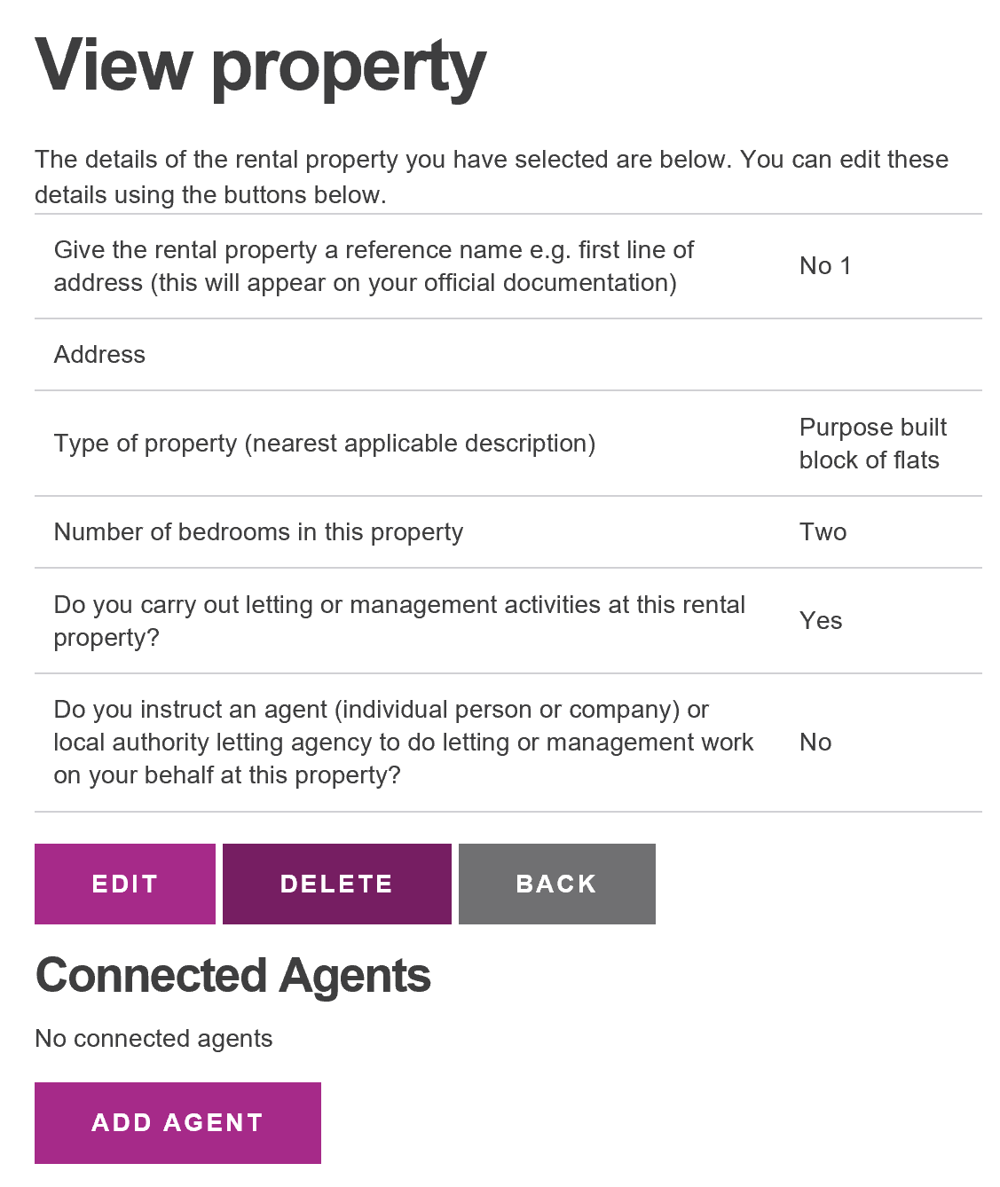

To complete the record:
First click on edit on the ‘View Property’ page. On this page you will find the postcode already shows with a ‘find address’ button below. Click this, and find the address in the drop down box that appears. If it cannot be found in the list, add it by clicking ‘address not in list’.
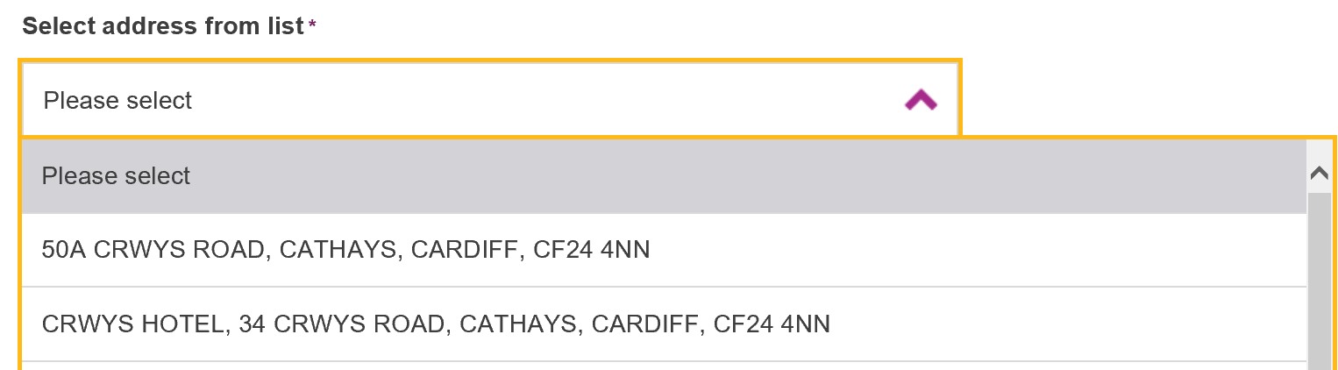
If you have an agent, you must now answer the last question and change it to ‘yes’.
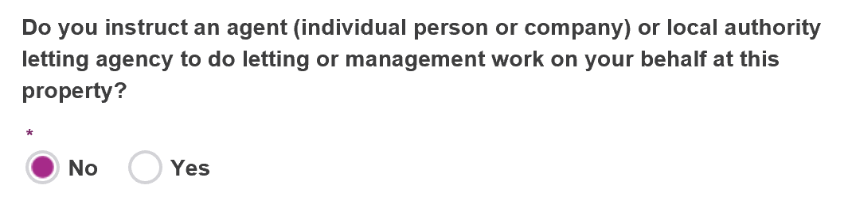
Once you have finished editing the information in this page click update.
If you have already entered an Agent Reference number within the CSV and it is entered correctly, the Agent will automatically be invited to link the property to their Agent Profile and you should find their details under the ‘Connected Agents’ details in the ‘View Property’ Section.

If you use an agent, and no agents are listed in the ‘View Property’ Page, you must ‘Add Agent’ by clicking the pink ‘Add Agent’ button. They will only show as ‘officially connected’ once they accept an email invitation from Rent Smart Wales to link with your rental property; this is done so the agent has the opportunity to confirm that they ‘let and/or manage it’.
Once you have finished updating your rental addresses, press back.

Then repeat the updating process with another property (by going through the yellow pencil) or press ‘Next’ to carry on with your Landlord Registration.

